Jazz Set 6 February 2023

Setlist

Summertime
"Summertime" is an aria composed in 1934 by George Gershwin for the 1935 opera Porgy and Bess.

Satin Doll
"Satin Doll" is a jazz standard written by Duke Ellington and Billy Strayhorn with lyrics by Johnny Mercer.^{[1]}
Blue Bossa by Kenny Dorham.
Girl From Ipanema
Brazilian bossa nova and jazz song. It was a worldwide hit in the mid-1960s and won a Grammy for Record of the Year in 1965. It was written in 1962, with music by Antônio Carlos Jobim lyrics by Norman Gimbel

Take 5
composed by saxophonist Paul Desmond and originally recorded by the Dave Brubeck Quartet for their album Time Out
Bouree
Bourrée in E minor is a popular lute piece, the fifth movement from Suite in E minor for Lute, BWV 996 written by Johann Sebastian Bach between 1708 and 1717.

Autumn Leaves Clapton
7 7 9 7 8 7 5 7 5 6 5 5 5 5 7 6 7 5
Em7 A7 Dmaj7
The falling leaves Drift by my window
3x4 4 3 3 x 4 5 6 5 x 2 4 2 3 2 2 2 2 4 4 3 2
Gmaj7 C#dim F#7 Bm
The falling leaves Of red and gold

Bm Em7 A7 Dmaj7
I see your lips The summer kisses

Gmaj7 C#dim F#7 Bm
The sunburned hands I used to hold

Bm C#dim F#7 Bm
Since you went away - The days grow long

Bm Em7 A7 Dmaj7
And soon I'll hear Old winter's song

6 7 8 6 8 6
Gmaj7 C#dim A#dim7 Bm
1 2 But I miss you Most of all My Darling

Bm C#dim F#7 Bm
When autumn Leaves Start to fall

Autumn Leaves - Nat King Cole

Em7 A7b9 DM7
The falling leaves drift by my window

GM7 C#m7b5 F#7 Bm7
The autumn leaves of red and gold

Em7 A7b9 DM7
I see your lips, the summer kisses

GM7 C#m7b5 F#7 Bm7
The sunburnt hands I used to hold

C#dim F#7 Bm7
since you went away the days grow long

Em7 A7 DM7
And soon I'll hear old winter's song

X 4 5 4 5 6 7 8 6 8 6
GM7 C#m7b5 A#dim7 Bm
1 2 But I miss you most of all my darling,

C#m7b5 F#7b9 Bm
When Autumn leaves start to fall

Autumn Leaves - Real Book

A-7 D7 Gmaj7 Cmaj7
The fall-ing leaves drift by the window

CM7 F#m7b5 B7 Em
The Autumn leaves of red and gold

A-7 D7 Gmaj7 Cmaj7
I see your lips the summer kisses
F#m7b5 B7 Em
The sun-burned hands I used to hold

F#m7b5 B7b9 Em
Since you went away the days grow long
A-7 D7
And soon I'll hear old win-ter's song
Gmaj7 F#7b5 B7b9 Em7 A7 Dm7 G7
But I miss you most of all my dar-ling
F#m7b5 B7b9 Em
When Au-tumn leaves start to fall
F#m7b5 B7b9 Em
When Autumn leaves start to fall
  - Justin Guitar – Chords only
  - Sandra Sherman – Chord Melody –

So What https://youtu.be/e5LahFc53TU

Blue Bossa ***
Kenny Dorham. Lyrics by Kitty King d=135
D=100

1 Cm7 Fm7 Fm9 Fm7 1 2
That moment just before the black of night.

Dm7b5 G7#9 G7b9 Cm7 Cm11 Cm7 3
Just before the sky gives up – it’s light.

Ebm7 Ab13 Ab7 DbM7 4
Just before the stars are tiny drops of steel.

Dm7b5 G7#9 G7b9 G7#9 G7b9 Cm7 G7#9 5
Night is blue Blue is what I feel.

1 1
The world is upside down. The sky below.

Answered by the sea and in it’s flow.

Everything is blue and only blue is real.
1 1 1
Night is blue; Blue is what I feel.

Solo

The trees are filled with night a shadow view.

Silhouettes of black against the blue.

Night is standing proud while mountains gently kneel
1 1 1
Night is blue; Blue is what I feel.

That moment when the night is standing by

When the light is falling from the sky

When the wishing stars are waiting to be real

1 1 1
Night is blue; Blue is what I feel.

Night is blue; Blue is what I feel

Blue Bossa is a popular bossa nova standard written by Kenny Dorham and made famous by Joe Henderson.
. Lyrics by Kitty King

Girl from Ipanema
Brazilian bossa nova and jazz song. It was a worldwide hit in the mid-1960s and won a Grammy for Record of the Year in 1965. It was written in 1962, with music by Antônio Carlos Jobim lyrics by Norman Gimbel

Girl from Ipanema
D = 100 https://youtu.be/Hgyf-2YkiMY Samdra Sherman
FM9
Tall and tan and young and lovely
G13
The girl from Ipanema goes walking,
Gm7 F#7 (C7) FM7 (Gb7b5)
And when she passes, each one she passes goes, "Ahhh."

FM7
When she walks, she's like a samba
G13
That swings so cool and sways so gentle,
Gm7 C7 FM7
That when she passes, each one she passes goes, "Ahhh."

Bridge:

F#M7 B9 B7
Oh, but I watch her so sadly;
F#m7 D9 D7
How can I tell her I love her?
Gm7 Eb9 Eb7 6 fret
Yes, I would give my heart gladly,
Am7 (5) (D7b9#11)
But each day when she walks to the sea,
Gm7 (3) C7 (3)
She looks straight ahead, not at me.

FM7
Tall and tan and young and lovely
G13
The girl from Ipanema goes walking,
Gm7 C13
And when she passes, I smile,
FM7 Gb7b5 FM7 Gb7b5
But she doesn't see, no she doesn't see

I Can't Stop Falling in Love with You
D A Bm D A

D F#m Bm G D A
Wise men say, only fools rush in
G A Bm G D A D
but I can't help falling in love with you

D F#m Bm G D A
Shall I stay, would it be a sin?
G A Bm G D A D
If I can't help falling in love with you

F#m C#7 F#m C#7
Like a river flows surely to the sea
F#m C#7
Darling so it goes
F#m B7 Em A
some things are meant to be - e

D F#m Bm G D A
Take my hand, take my whole life too
G A Bm G D A D
for I can't help falling in love with you

F#m C#7 F#m C#7
Like a river flows surely to the sea
F#m C#7
Darling so it goes
F#m B7 Em A
some things are meant to be - e

D F#m Bm G D A
Take my hand, take my whole life too
G A Bm G D A D
for I can't help falling in love with you
G A Bm G D A D
for I can't help falling in love with you

I got Rhythm
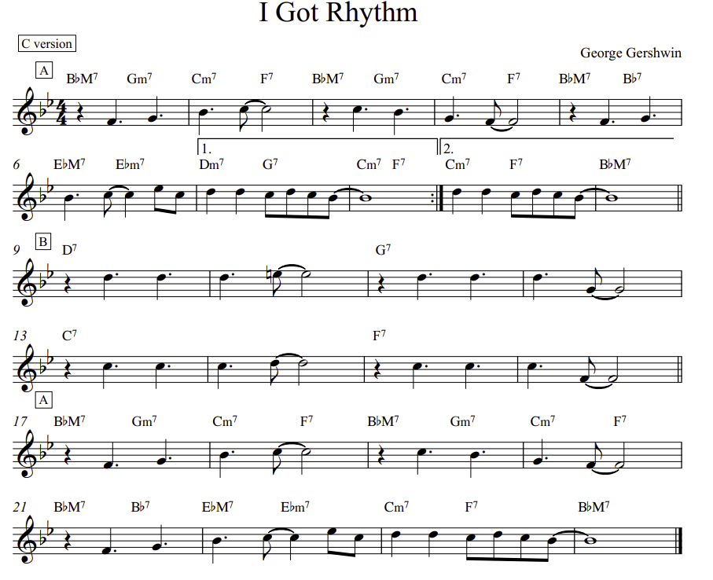

I got rhythm lyrics ****

https://youtu.be/Tp18BXa417c - Rhythm Changes – Sandra Sherman

I got rhythm 2 4 2 4
I got music 4 2 4 2
I got my gal 2 4 2 4
Who could ask for anything more?
2 4 1 1 4 1 4 2

I got daisies
In green pastures
I got my gal
Who could ask for anything more?
Ol'Man Trouble 1 1 1 3
I don't mind him 1 1 1 4
You won't find him 4 4 4 1
'Round my door 4 4 2
I got starlight 2 4 2 4
I got sweet dreams 4 2 4 2
I got my gal 2 4 2 4
Who could ask for anything more?
2 4 1 1 4 1 2 4
Who could ask for anything more?
2 4 1 1 4 1 4 2

Satin Doll *
https://youtu.be/dV6Ed3EiqGM -- Sandra Sherman
D-7 G13 D-7 G13
Cigarette holder which wigs me
E-7 A13 E-7 A13
Over my shoulder, she digs me.
A-7b5 Ab-9 Bb7 CM7 Bb13 A7#5
Out cattin' my satin doll.

Baby, shall we go out steppin?
Careful, amigo, you're flippin',
Speaks Latin my satin doll. C6/9 B6/9 C6/9

D-11 C7
She's nobody's fool so I'm
FM7 F6/9 E6/9 F6/9
playing it cool as can be.
A-11 D7
I'll give it a whirl but I
A-11
ain't for no girl catching me,
A7#9 A7b9
swich-e-rooney.

Telephone numbers well you know,
I’m doing my rhumbas with uno
And dancing my satin doll.

"Satin Doll" is a jazz standard written by Duke Ellington and Billy Strayhorn with lyrics by Johnny Mercer.^{[1]}

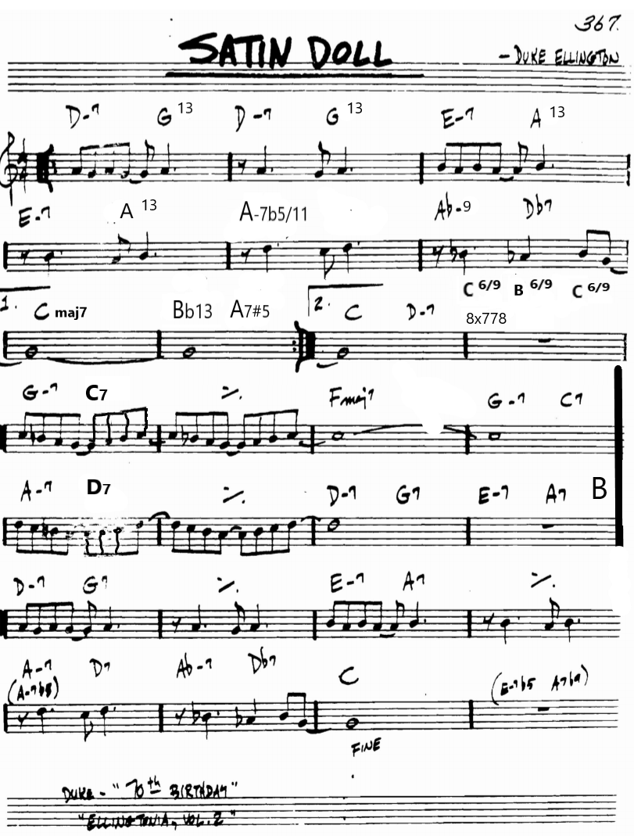

Send in the Clowns
Words & Music by Stephen Sondheim
Recorded by Judy Collins, 1975
From the musical "A Little Night Music"

G A7 D G A7 D
Is - n't it rich? Aren't we a pair?

A7 D A7 D D7 G
Me here at last on the ground, and you in mid-air --

Em G D Em - G - D
Send in the clowns.

G A7 D G A7 D
Is - n't it bliss? Don't you approve?

A7 D A7 D D7 G
One who keeps tear - ing around, and one who can't move.

Em G D Em G D
But where are the clowns? Send in the clowns.

Bridge:

C#7 F#m Bm7 F#m
Just when I stopped opening doors,

C#7 F#m Bm F#m Bm
Finally knowing the one that I wanted was yours;

F#m E7 F#m E7
Making my entrance again with my usual flair,

Bm7 F#m7 Em7 A7
Sure of my lines -- no one is there.

G A7 D G A7 D
Don't you love farce? My fault, I fear;

A7 D A7 D DM7 D7 G
I thought that you'd want what I want - sorry my dear.

Em G A7 Em G A7
But where are the clowns? Quick, send in the clowns.

Em G A7 D
Don't bother, they're here.

G A7 D G A7 D
Is - n't it rich? Is - n't it queer,

A7 D A7 D DM7 D7 G
Los - ing my tim - ing this late in my career?

Em G A7 Em G A7
But where are the clowns? There ought to be clowns...

Em G A7 D
Well, maybe next year.

Summertime
3 4 Am E7 Am 1 2 Am E7 Am 2
Summertime, and the livin' is easy
Dm7 C6 Fmaj7 2 E7-F7- E7
Fish are jumpin' and the cotton is high
Am E7 Am E7 Am E7 Am
Your daddy's rich, and your momma's good lookin' 1 2 3
4 C6 F#7-5 Fmaj7 Am
So hush little ba by, don't you cry

2 3 4 Am E7 Am E7 Am 2
One of these mornings, you're gonna rise up singing
Dm7 C6 Fmaj7 2 E7-F7- E7
Then you'll spread your wings and you'll take to the sky
Am E7 Am E7 Am
But till that morning, there's a nothin' can harm you
4 C6 F#7-5 Fmaj7 Am
With daddy and mamm y stan- ding by

[Outro]
C6 F#7-5 Fmaj7 Am E7 Am
With daddy and mammy stan- ding by

https://youtu.be/VFiaNrkGdsU

"Summertime" is an aria composed in 1934 by George Gershwin for the 1935 opera Porgy and Bess.

Take the A Train ***

  - Duke Ellington
  - Ella Fitzgerald –
  - Sandra Sherman – Chord Melody
  - Jens Larsen – Chord Magic

C6/9 | % | D9#11 | % | D-7 | G9 | C6 | D-7 G9 | phrase 1

Tammy -- in C
d -75 3/4
C Em F C
I hear the cottonwoods whispering above
Em Am Dm G6
Tammy Tammy Tammy's in love
C Em F C
The ole hooty owl hooty hoos to the dove
Em F G7 C
Tammy Tammy Tammy's my love / C Em F C / Em Am Dm G6/
F / C Em F C / Em F G7 C /
Does my lover feel what I feel / F / D7 G7 /
D7 G7 / E7 Am / F C Em Am G7 /
When she comes near / C Em / F C / Am Em G7 C /
E7 Am
My heart beats so joy-fully
F C Em Am G7
You'd think that she could hear
C Em
Wish I knew if she knew
F C
What I'm dreamin' of
Am Em G7 C
Tammy Tammy Tammy's my love

C Em F C
Whippoorwill, whippoorwill, you and I know
Em Am Dm G6
Tammy! Tammy! Can't let her go!
C Em F C
The breeze from the bayou keeps murmuring low,
Em F G7 C
"Tammy! Tammy! I love her so!"
C F D7 G7
When the night is warm, soft and warm, I long for her charms!
E7 Am C Em Dm7
I'd sing like a violin if I were in her arms.
G7 C Em F C
Wish I knew if she knew what I'm dreaming of!
F Em Dm7 G7 C
Tammy! Tammy! Tammy's my love

Tammy -- in G
d -75 3/4
G Bm C G A Bb C D E F G
I hear the cottonwoods whispering above E F G A B C D
Bm Em Am D6 (10)
Tammy Tammy Tammy's in love
G Bm C G
The ole hooty owl hooty hoos to the dove
Bm C D7 G
Tammy Tammy Tammy's my love
C
Does my lover feel what I feel
A7 D7
When she comes near
B7 Em
My heart beats so joy-fully
C G Bm Em D7
You'd think that she could hear
G Bm
Wish I knew if she knew
C G
What I'm dreamin' of
Em Bm D7 G
Tammy Tammy Tammy's my love

C Em F C
Whippoorwill, whippoorwill, you and I know
Em Am Dm G6
Tammy! Tammy! Can't let her go!
C Em F C
The breeze from the bayou keeps murmuring low,
Em F G7 C
"Tammy! Tammy! I love her so!"
C F D7 G7
When the night is warm, soft and warm, I long for her charms!
E7 Am C Em Dm7
I'd sing like a violin if I were in her arms.
G7 C Em F C
Wish I knew if she knew what I'm dreaming of!
F Em Dm7 G7 C
Tammy! Tammy! Tammy's my love

